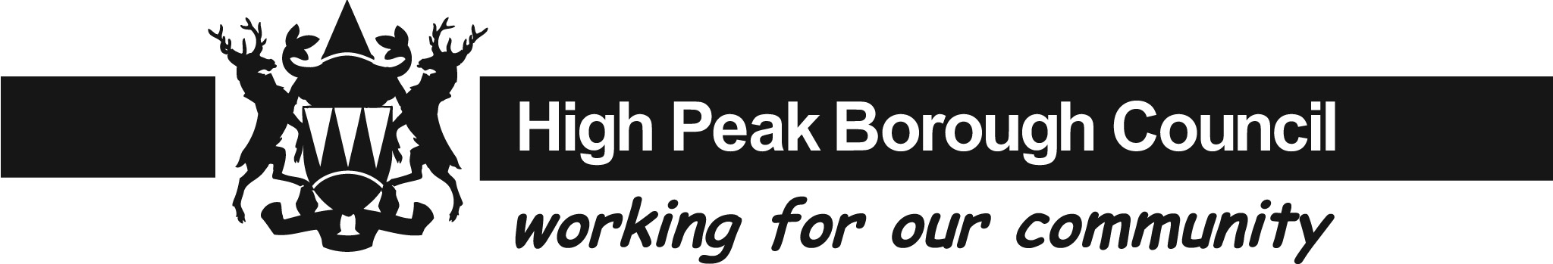

Rural Rate Relief Application Form

Name(s) of Ratepayers (for joint ratepayers or partnerships, please provide all names and titles):

Correspondence Address:

Telephone Number:
Email Address:

Trading Name of Organisation: Property Address:

Account Reference Number (as shown on your bill):

Rural settlement area where business premises are located:

Percentage
Nature of the business: please tick all applicable boxes. For each box  that is ticked, please indicate the percentage of the business that fulfils this description. | General Store
 | Post Office
Village shop (selling mainly food for
human consumption)
 | Public House
 | Petrol Station
If your business is not one of the above, please indicate here the nature of your business:

Is the business the only one of its type in the settlement area? Yes No

If the business sells food for human consumption or general household goods, please indicate below the categories of goods for sale and the proportion of sales or floor space of these goods:

Food for human consumption: General household goods:

Other goods including confectionary or fast food, please list these goods separately:

Declaration

I confirm that the information given above is true and accurate and I agree to inform the authority should I have any change in my circumstances.
Signature:
Print Name:
Capacity of person signing (owner, tenant, agent, director, partner etc):
Date:

Important Notice

The application must be signed by the ratepayer. Where, for example, the ratepayer is a company or partnership, it should be signed by a director of that company or one of the partners and the person signing should state his capacity.
It is a criminal offence for a ratepayer to give false information when making an application for Relief.
Changes of circumstances should be declared promptly. Failure to report a change within 4 weeks will result in the loss of
relief.

Additional Information

The occupier of a property in a settlement, appearing in a billing authority’s rural settlement list is entitled to rate relief if it is the only such property of that type in that settlement and its rateable value is £7,000 or less changing to £8,500 with effect from 1st April 2010 (£10,500 in the case if a Public House and Petrol Filling Station, changing to £12,500 with effect from 1st April 2010). The relief given is now 100% as of the 1st April 2017.

Authorities also have discretion to remit all or part of the rate bill on other properties in a settlement on the rural settlement list if the rateable value is £14,000 or less, changing to £16,500 with effect from 1st April 2010, and the local authority is satisfied that the property is used for a purpose which benefits the local community.

Rural Settlement Areas within High Peak
In accordance with the Local Government and Rating Act 1997 (LGRA 1997), a total of 35 Rural Settlement Areas (RSAs) have been designated within the High Peak as follows:-

Aston Hayfield
Bamford Hope
Birch Vale King Sterndale
Bridgemont Little Hayfield
Brookbottom New Smithy
Brough Peak Dale
Buxworth Peak Forest
Castleton Rowarth
Chapel Milton Shatton
Charlesworth Small Dale
Chinley Sparrowpit
Chisworth Sterndale Moor
Combs Thornhill
Dove Holes Thornsett
Edale Tunstead Milton
Furness Vale Whitehough
Fernilee Wormhill
Hague Bar

Privacy Notice
Our privacy notice provides more information about what we do with personal information.
You can see our privacy notice at www.highpeak.gov.uk/YourData or by contacting our team on the telephone number below.

High Peak Borough Council, P O Box 136, Buxton, SK17 1AQ
Telephone: 0345 1294858
www.highpeak.gov.uk

